How to Skin Talent Studio

New client skinning
The first thing to do when we need to create a skin for a new client is to create the appropriate directory to hold their customisations. The location of this new directory must go under <Talent Studio project root dir>/talentstudio-views/web/clients/
The new directory must not contain any spaces

Client directories
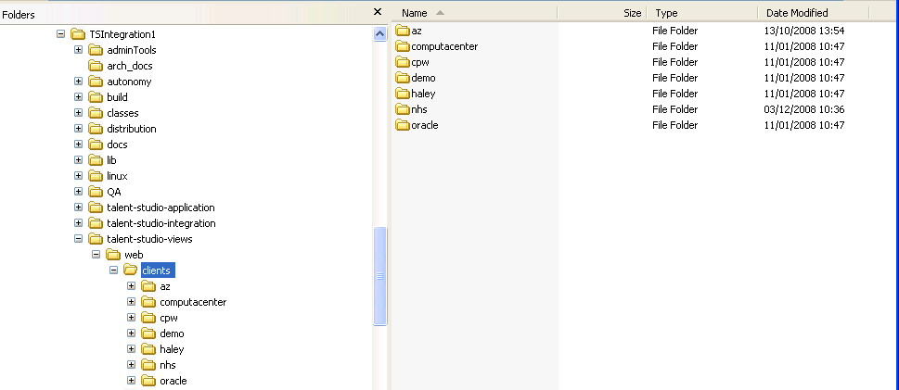
My project root directory
Client’s directory
Where new client directory will go

Once we have the client directory we need to supply the client specific information below this, the minimum requirements would generally be a style sheet for the company’s colour scheme and a specific company logo which will be placed under images; this will be covered in more details later on in this document.

The things that can be customised within Talent Studio are images, colours, layout, language files and the help files. Colours and layout are handled by providing a style.css that will go under a styles directory which is a sub-directory of the client folder just created. All Images, the logo, and any other images currently used by default can be overridden with different images but with the same name. The language file(s) go under a sub-directory of the new client directory with path /resources/language/

